Component Connection Guide

# Heat Sensor

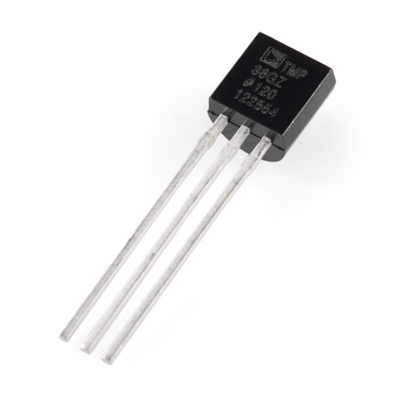



## Code to add to setup:

pinMode(pinNumber, INPUT);

## Code to add to loop to read value:

int rawVoltage = analogRead(pinNumber);

## Code to add to loop to convert voltage to Celsius

float celsius = ((rawvoltage/1024.0) * 5000 / 10);

# Light Sensor

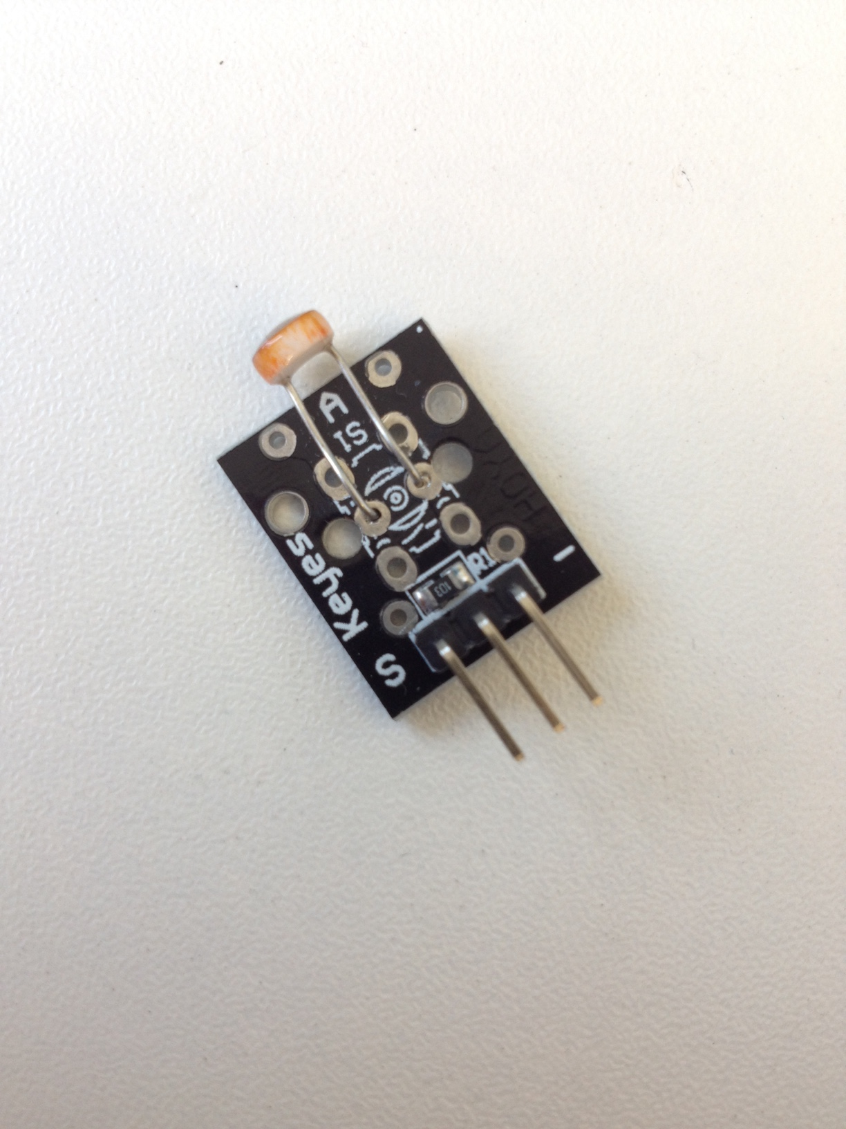



## Code to add to setup:

pinMode(pinNumber, INPUT);

## Code to add to loop to read value:

int lightValue = analogRead(pinNumber);

### Range of values received = 200 - 1200

# LED



- Short leg into Ground

- Add a resistor to bridge the LED to the other side of the board

- Connect wire from resistor to a pin (2-13)

## Code to add to setup:

pinMode(pinNumber, OUTPUT);

## Code to add to loop to turn LED on:

digitalWrite(pinNumber, HIGH);

## Code to add to loop to turn LED off:

digitalWrite(pinNumber, LOW);

# Buzzer



- Pin 2-13 to + side (or longer leg side)

- Ground to other side

## Code to add to setup:

pinMode(pinNumber, OUTPUT);

## Code to add to loop to have the buzzer make a noise:

tone(pinNumber, frequency, duration);

### 

### Frequency Range: 200 – 900

### Suggested duration: 200